WEATHER ANALYSIS

This project presents a comprehensive weather analysis system utilizing an Arduino UNO integrated with multiple sensors to monitor environmental conditions. The system incorporates a DHT-11 sensor for measuring temperature and humidity, an LDR for light intensity, and a BMP-180 for altitude and atmospheric pressure. Additionally, it features a wind speed control module to assess wind conditions and an MQ-136 sensor for air quality monitoring, specifically detecting harmful gases.
Data collected from these sensors is processed and displayed on an LCD screen for real-time monitoring. The system is further enhanced with an ESP8266 Wi-Fi module, enabling wireless data transmission to a cloud server for remote access and analysis. This multi-faceted approach not only facilitates localized weather monitoring but also contributes to broader environmental data collection, making it a valuable tool for researchers and enthusiasts alike. The integration of these components creates a user-friendly and efficient weather station, promoting awareness of local climatic conditions and air quality.

The major building blocks of this project are:
- Rps.
- Arduino Uno.
- Dht11 Sensor.
- Lcd Display.
- Esp8266 Wi-Fi Module.
- Bmp 180
- Mq136.
- Ldr.
- Wind Speed Sensor.
- Thingspeak.

Software’s used in the project:

- Arduino IDE.
- Express SCH for Circuit Design.
- THINGSPEAK CLOUD.

Regulated Power Supply:
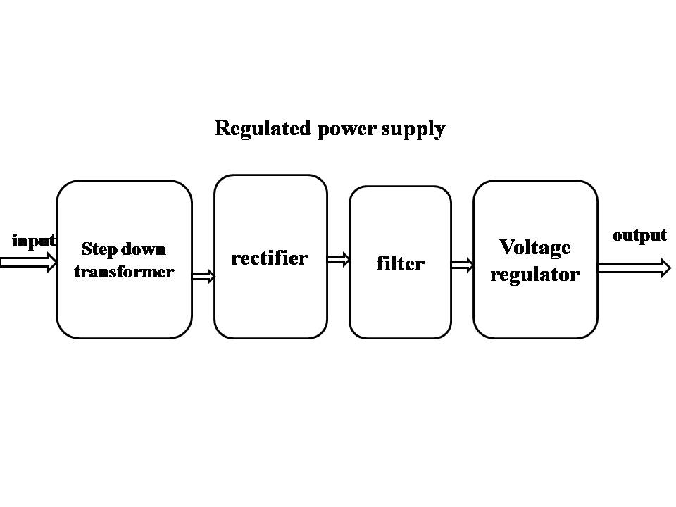

Block diagram:

